Keith Wheeler

CS165

Brother Comeau

Project 4

Asteroids

Problem Description – A game that shows a ship shooting a bunch of asteroids.

Overview – The game will allow a user to control a ship and shoot asteroids into millions of pieces.

Interface Design –

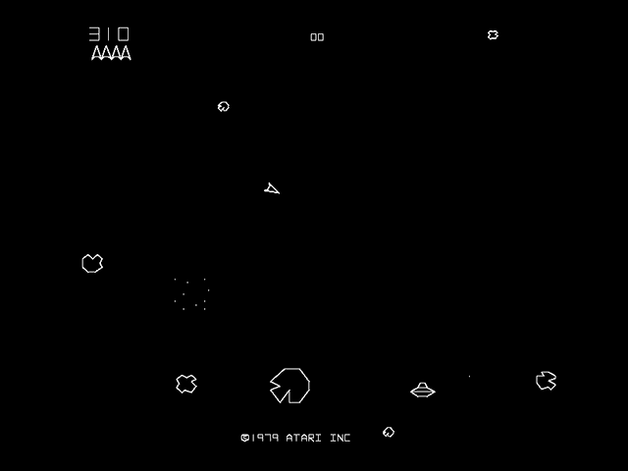 The number of bullets left will be shown in the upper left corner. The points will be shown in the top middle portion of the screen. The ship will be able to move around and spin and will fire bullets from the front. The asteroids will start as circles and will blow up into a million pieces per shot.

Structure Chart –

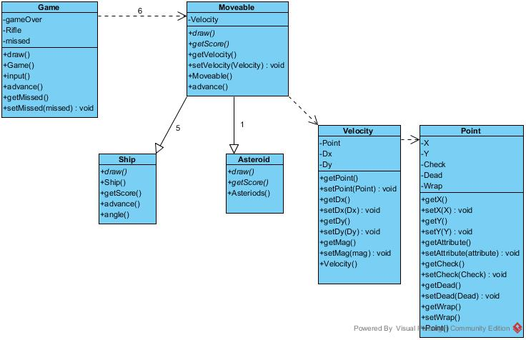

Data Structures – Point has a float X and a float Y coordinate to show what position the object has. Velocity has a float Dx and a float Dy to show the point the object will move to. The score will be passed as an integer to game. Angle will show the angle of the ship to game so that the bullet can go the right direction.

Algorithm Design –

Error Handling –